MEMORANDUM
To: File
Subject: Update of earth shielding thickness for Halls A, B, C and LERF
Date: April 25, 2016
From: Keith Welch

This memo documents the results of the evaluation of the latest soil thickness data for end stations A, B and C and the LERF (attachment A). The elevation survey was conducted in March of 2014, via aerial survey methods. The precision of the data is stated to be good to +/- 3 inches. This evaluation is provided to update the five-year measurement requirement for earth overburden in the FSAD for the four locations noted. The report of the survey results is appended to this note as Attachment A.

Evaluation of Halls A, B and C Domes

As an aid in assessing earth thickness, data points from previous physical surveys of Hall A and C are overlaid on the topographic views of the halls in the survey report. Visual inspection reveals close correlation to the previous survey. Another check on these values can be made by comparing them to the elevations in the civil design specifications. Attachment B shows the specifications for elevations of the end station soil berms. Again, inspection shows close correlation between the 2014 survey elevations and the design specifications. In addition, the survey data report contains a cross-sectional cut for each hall and beam dump tunnel, with overburden thickness values along the cross section. These are compared to the design specifications for the halls. The shielding survey gives dome earth thicknesses at incremental distances along the cross-sectional hall diameter, normal to the dome curvature at each location. These are compared to the design specifications given in CEBAF-TN-97-017, which forms the basis of the FSAD shielding requirements. The Tech Note provides thicknesses for total “concrete equivalent” dome shielding in the “center” and “outer” areas of each dome. Following methodology set out in JLAB-TN-16-005, the inner radius is taken to be about 85% of the total radius of the hall. A spreadsheet is used to evaluate design thickness against measured values. Original design requirements from TN-97-017 are shown in Table 1. These values were generally rounded up in the facility construction specifications, but here we compare to the actual required thickness.

Table 1
Hall | Average Conc. Eq. Thickness (inner) ¹ | Design reqmt. (inner) ¹ | Delta ¹ | Average Conc. Eq. Thickness (outer) ¹ | Design reqmt. (outer) ¹ | Delta ¹
A | 3.82 | 3.94 | -0.12 | 4.07 | 4.92 | -0.85
B | 5.59 | 3.94 | 1.65 | 8.14 | 4.92 | 3.22
C | 6.03 | 5.25 | 0.78 | 6.12 | 6.23 | -0.11
¹Values are in feet

Beam Dump Shielding

In addition to the domes, the beam dumps are heavily shielded by concrete and earth overburden. Design requirements for this shielding are also found in TN-97-017. By inspection of the survey report it can be easily seen that the dump berms meet or exceed their design specification thickness.

Note that the additional concrete around the Hall B dump is not shown on the drawing due to the location of the sectional cut. Table 2 shows the design requirement for dump shielding. These values were also rounded up for construction purposes, as shown.
Table 2
Hall | Design reqmt. ¹ |  | Construction Spec ¹
 | Concrete | Earth | Concrete | Earth
A & C | 15 | 13 | 15 | 15
B | 12.5 | 16 | 12.5 | 17.5
¹ Dimensions in feet

Evaluation of LERF

The Low Energy Recirculation Facility (LERF) has only lateral earth berms, being shielded vertically by the concrete vault roof and floor of the klystron gallery, in combination with soil fill between. No degradation of the building structure is evident or suspected. The berm elevations shown on the aerial survey are comparable to those found in the facility specifications (see Attachment C). Some settlement of the sidewalk on the north berm is evident, and repairs were made in 2015 to a small area affected by erosion, as noted in the report. Periodic visual inspections are conducted on this berm, as well as the others, to identify and correct any significant degradation.

Assessment:
Clearly, all of the shielding on the domes and beam dumps of halls A, B and C are acceptable with respect to the design requirements and ASE limits. Average thicknesses of the cross sectional data for Halls A and C agree with analyses from 2011 and 2013, respectively, within statistical error. Due to the positioning and geometry of Hall B, the berms on the dome and the dump are significantly thicker than required, as has been understood for some time. The depiction of the concrete thickness of the ceiling of Hall B is incorrect, but dimensions used were taken from design drawings which have the correct values. Some settling, erosion and activity of animals has occurred in some locations, and these have been addressed by Facilities Management when noted. None of those phenomena appear to have significantly impacted the effectiveness of the shielding.

Conclusion:
We conclude that the permanent earth shielding associated with Halls A, B, C and LERF meets the requirements of the FSAD and ASE. This evaluation is considered valid until March 1, 2019.

Additional marked-up sketches of specific locations are provided in Attachment D. These were used to note corrections on the survey report and to derive concrete/earth thickness estimates where roof thicknesses vary.

Attachment A
Facilities Shielding Survey, March, 2014 Data
Source: https://jlabdoc.jlab.org/docushare/dsweb/View/Collection-28995
Page 1 of 5
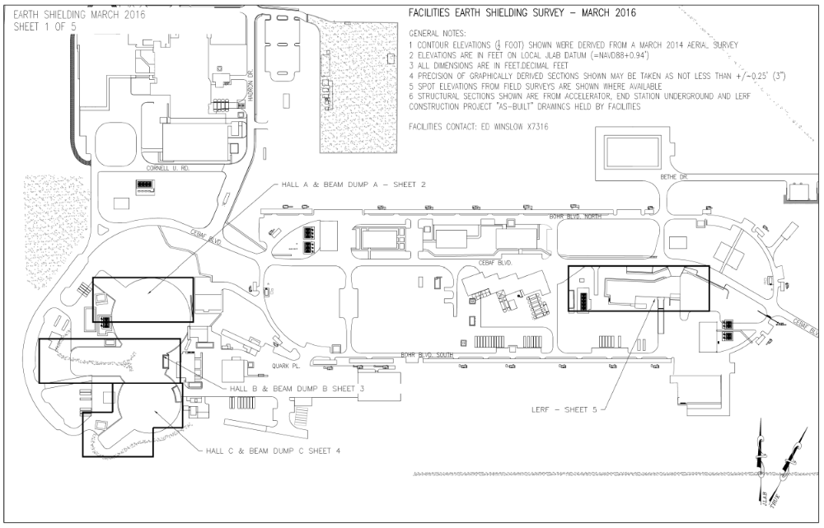

Attachment A
Facilities Shielding Survey, March, 2014 Data
Page 2 of 5
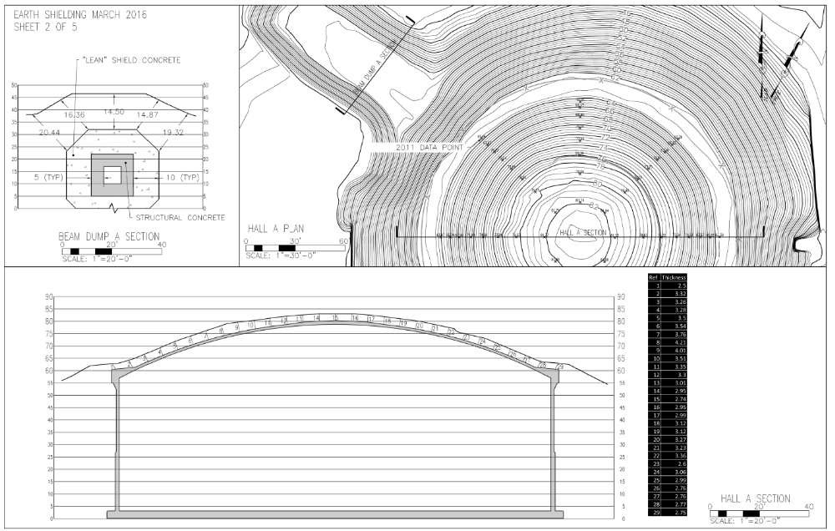

Attachment A
Facilities Shielding Survey, March, 2014 Data
Page 3 of 5
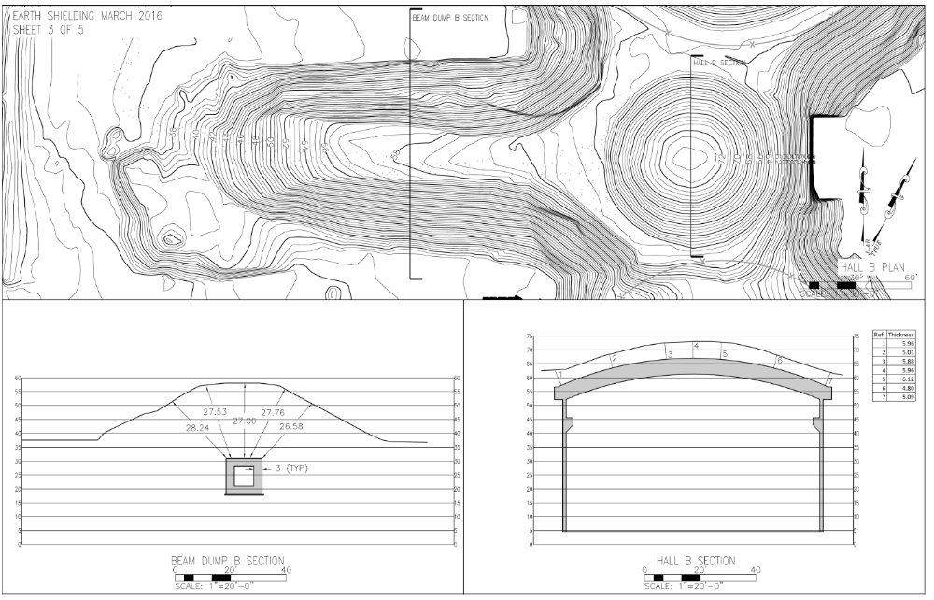

Attachment A
Facilities Shielding Survey, March, 2014 Data
Page 4 of 5

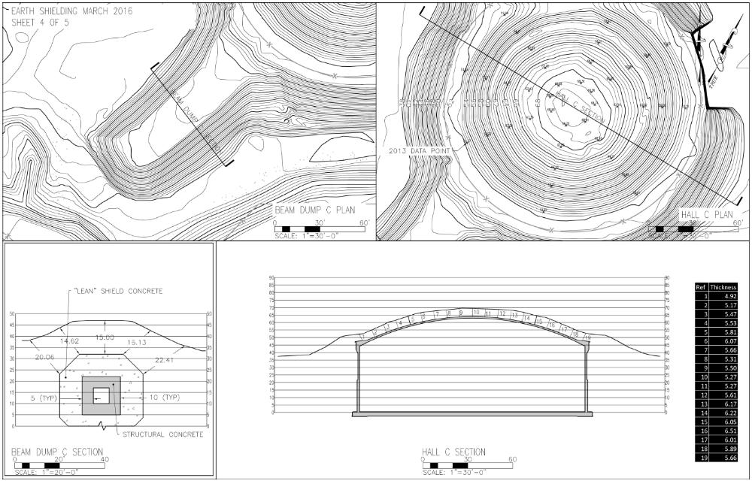
Attachment A
Facilities Shielding Survey, March, 2014 Data
Page 5 of 5
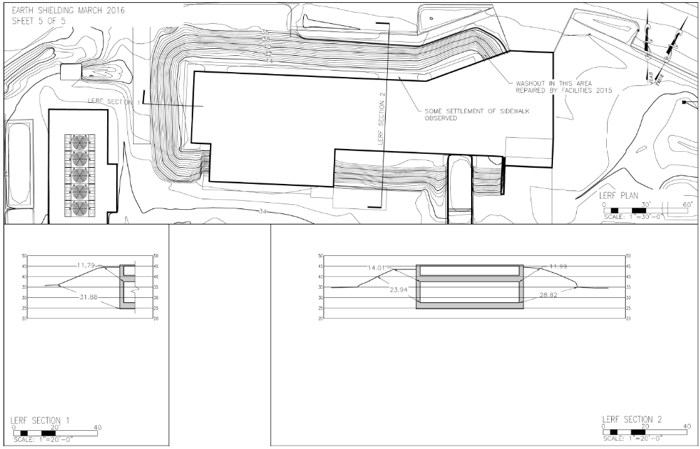
Attachment B
Design drawing showing earth berm construction requirements for Halls A, B and C
Source: M:\facilities\Projects\Completed Projects\Site\End Station Above Ground\Volume 1\Individual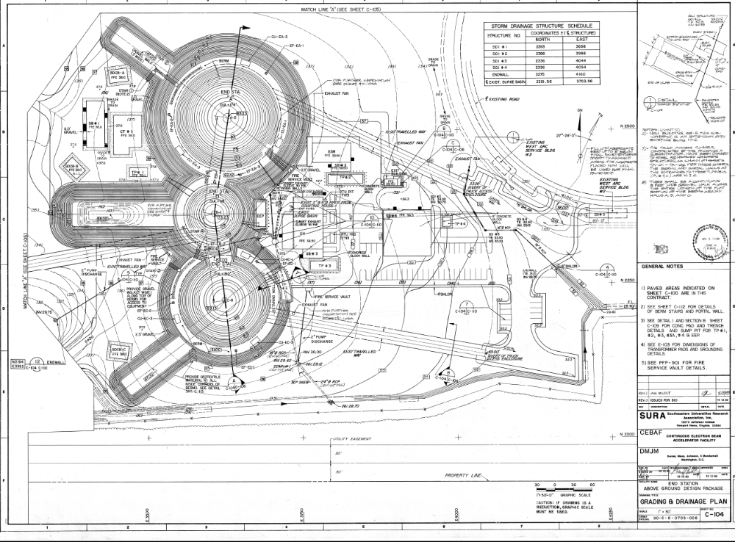
Attachment C
LERF (FEL) construction cross section showing berm elevation
M:\facilities\Projects\Completed Projects\Buildings\18 FEL

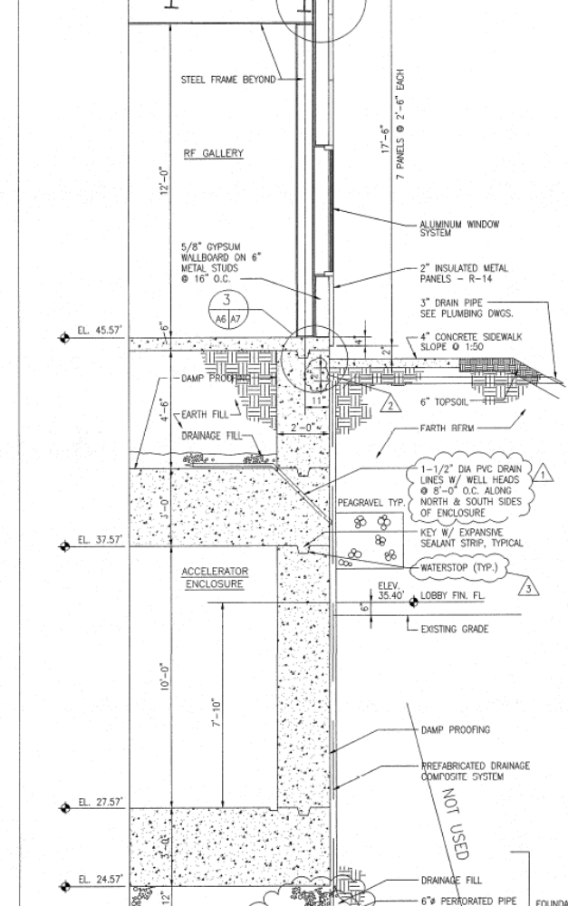

Attachment D
Sketches and notes regarding end station roof/berm thickness
Page 1 of 3
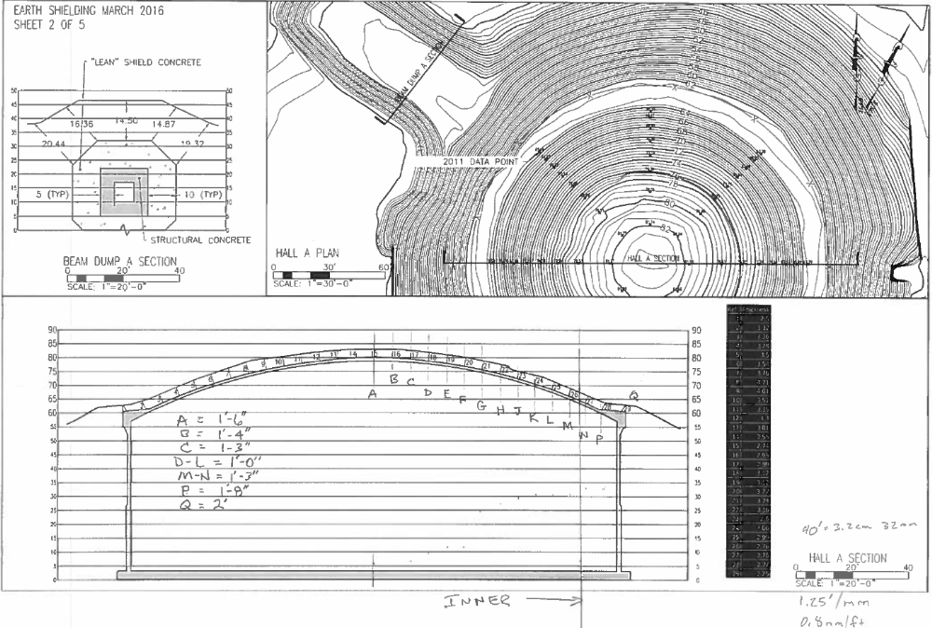

Attachment D
Sketches and notes regarding end station roof/berm thickness
Page 2 of 3
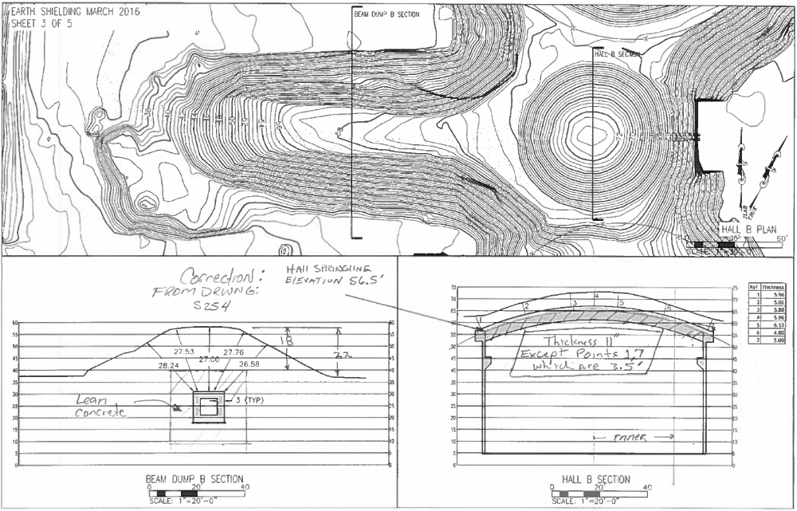

Attachment D
Sketches and notes regarding end station roof/berm thickness
Page 3 of 3
